Eniris API

Page / - last modified by Bart Verheecke on 2024/01/15 21:46

Eniris API
last modified by Bart Verheecke
on 2024/01/15 21:46

Table of Contents
Eniris Authentication APIs
Eniris Metadata & Telemetry Query API
Telemetry Query API
Authorization Requirements
Server Response Codes
Collection for postman
Access timeseries data
Access a device (building/site)

Eniris Authentication APIs
Eniris provides Authentication APIs, facilitating access through both MQTT and HTTPS protocols. Detailed documentation and interactive features for these APIs are available at the following links:
- MQTT Authentication API: Click here
- HTTPS Authentication API: Click here

Eniris Metadata & Telemetry Query API
Additionally, Eniris offers a Metadata Query API, enabling users to retrieve telemetry-related data. The documentation for this API can be accessed via the following link:
https://api.eniris.be/docs/

Telemetry Query API
Specifically for telemetry data, Eniris provides the Telemetry Query API. This API requires a POST request to the following URL:
POST https://neodata-ingress.eniris.be/v1/telemetry
The following query parameters are mandatory when using the Telemetry Query API:
- u: Collector name
- db: Database
- rp: Retention policy
An example of a request to the Telemetry Query API might look like this:
https://neodata-ingress.eniris.be/v1/telemetry?u=klantennaam-ingress&db=klantennaam&rp=rp_one_m
[
{
"measurement": "exampleMetrics",
"time": "2023-08-02T10:00:00Z",
"tags": {
"serialNr": "aaaabbbbccccdddd"
},
"fields": {
"maximumProductionPower_W": 2000
}
}
]
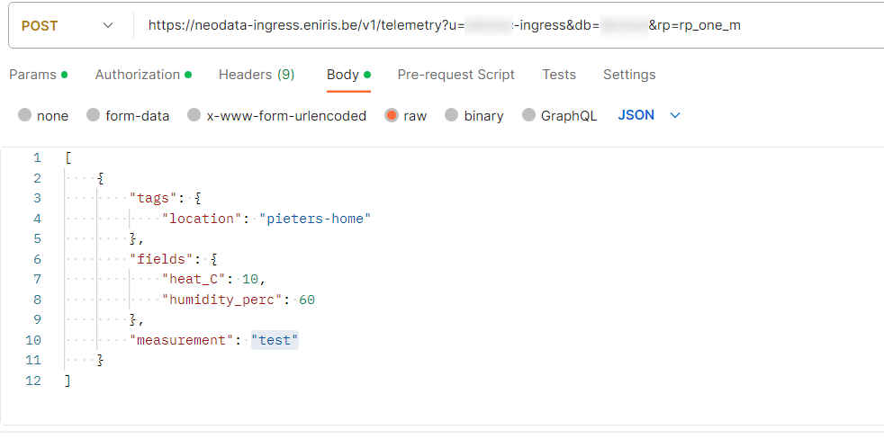

Authorization Requirements
For accessing the Eniris APIs, it is crucial to include a valid Bearer authorization token. This token must be obtained by logging in as a user who is a member of the specific "CustomerName" role. Failure to provide a token associated with a user in the correct role will result in a 403 Forbidden response, accompanied by an error message indicating unauthorized access or incorrect permissions.

Server Response Codes
When interacting with Eniris APIs, the server can respond with a limited set of HTTP status codes, each indicating a specific type of response or error:
- 204 No Content: Success, but no content in the body.
- 400 Bad Request: Various formatting errors in the request.
- 403 Forbidden: Authentication issues or incorrect permissions.
- 404 Not Found: Attempts to write to an unknown namespace.
- 409 Conflict: Conflicts with the allowed data time range or stored field types.
- 422 Unprocessable Entity: Internal data type inconsistencies within the sent message.

Collection for postman
Below is a script for postman that helps handle the token generation. (see appendix)
Influx via api.postman_collection.json

Access timeseries data
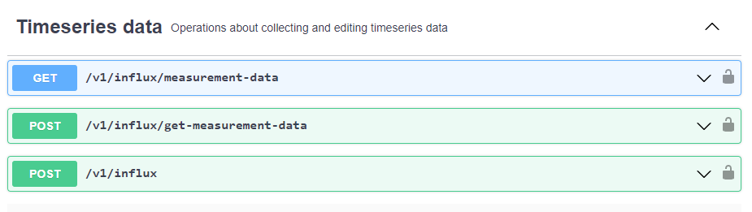

Access a device (building/site)
GET https://api.eniris.be/v1/device?id=37142
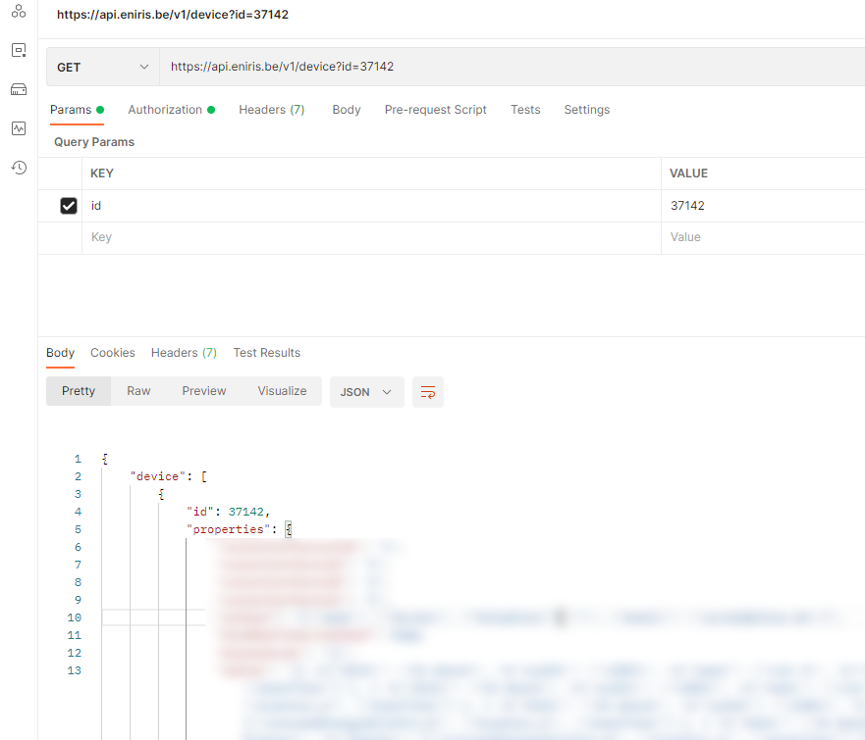
To edit a property, use POST:


